Hospital and Outreach Education Management Committee Biographies 2016-2017
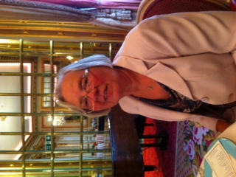 | Frances Jones  Chair of Management Committee (Community Member)  Chair of Finance and Resources Sub Committee  Chair of Personnel Sub Committee  Appointed: April 2014  Retired local government officer who worked 35 years for the local authority. All my working life has been in financial roles. My hobby has always been education and in particular collecting qualifications achieving a M. Ed., Adult Teacher status, NEBOSH and many more. I was a governor of the first school in Northampton to become an academy. Married with two children, 7 grandchildren and 1 great grandchild and two dogs.

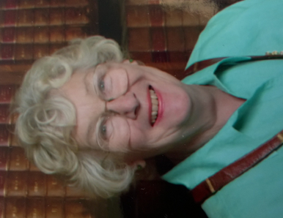 | Gina King (OBE)  Vice Chair of Management Committee (Community Member)  Member of Finance and Resources Sub Committee  Member of Personnel Sub Committee  Arts Governor  Appointed: April 2014  Gina was an elected member of Northamptonshire County Council for 46 years and served as chair of various committees including education and finance.  Gina has lots of experience of school governance, having been actively involved in schools in her area for many years.  Gina is married with 4 children, 6 grandchildren, 3 step children and 4 step grandchildren. Her hobbies include traveling, collecting contemporary painting and sculpture, her dogs, gardening and drawing.

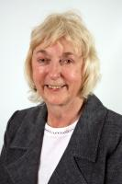 | Councillor Joan Kirkbride (Local Authority Member)  Member of the Learning and Curriculum Sub Committee  Appointed: June 2015  Joan is married with two sons and three grandchildren. She joined the Civil Service when she left school and worked for the Inland Revenue. After a break looking after her children she worked in the Department for Social Security before moving to the Department for Health in Whitehall. In 1967 she took early retirement and was elected to Northamptonshire County Council where she represents the Bugbrooke division. During her 20 years as a councillor she was Cabinet member for children from 2005 to 2009, Deputy Leader from 2009 to 2013 and Chairman of the Council from 2013 to 2015. She has also chaired the Corporate Parenting Board and sits on the Adoption Panel.  Joan is a Governor for Campion School and sits on many children’s charities including the Nene Valley Care Trust, which helps young people leaving care, and the Northamptonshire Music and Performing Arts Trust. She is also Chairman of NORPIP.

Lisa McGarrity (Community Member)
Chair of Learning and Curriculum Sub Committee
Appointed: September 2016
Lisa works as an officer for the Information Advice Support Service (IASS), which was previously known as Northamptonshire Parent Partnership Service (NPPS). IASS supports parents, carers and young people with all matters relating to Special Educational Needs and Disability. Lisa joined IASS in September 2015 after working as a primary school teacher for seventeen years. During that time, she was a Deputy Head Teacher, taught all year groups and served as a teacher representative on the school’s governing body.
In her spare time, Lisa likes to go spin class at the gym and she is building up her fitness at the local weekly Park Run. She enjoys taking part in sporting events and has recently completed the Cynthia Spencer 50 mile bike ride in Northamptonshire.

Lisa is interested in the workings of Hospital and Outreach and how young people are supported to return to mainstream provision, when possible. In addition, I would like to learn about how the national curriculum is adapted to suit young people at the various Hospital and Outreach settings.

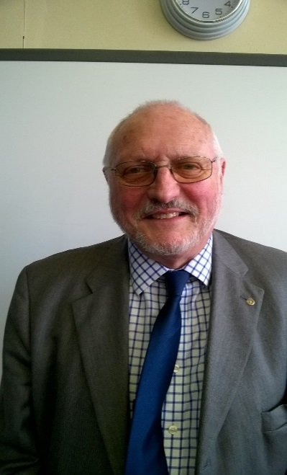 | Graham Goss (Community Member)  Member of Finance and Resources Sub Committee  Member of Personnel Sub Committee  Careers and Enterprise Education Governor  Appointed: October 2015  Graham joined the governing body after supporting the PRU in his role as our enterprise advisor. Graham is the senior partner in HW Chartered Accountants in the area, and is involved in the management of the 4 offices around Northamptonshire.  Graham has a wife and 3 children and is an active member of the Northamptonshire Enterprise Programme, and is involved in the Northampton branch of the Federation of Small Businesses.

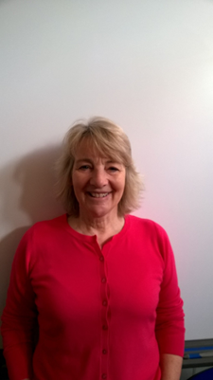 | Valerie King (Community Member)  Member of Finance and Resources Sub Committee  Member of Personnel Sub Committee  Looked After Children Governor  Appointed: June 2015  Val is a retired nurse: she was previously the designated nurse for looked after children so is ideally placed to fulfil this role on our management committee.  Val is also a volunteer at Delapre Abbey and enjoys doing agility with her dog in her spare time.

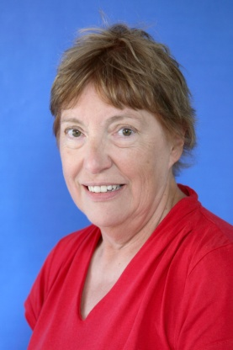 | Paula Fuller (Teacher Staff Member)  Member of the Learning and Curriculum Sub Committee  Safeguarding Governor  Appointed: September 2016  Paula is a very experienced teacher who has taught over a variety of settings. She joined Hospital and Outreach Education 15 years ago and is currently our Leader of Learning for the North of the county.  Paula is married with 3 children and lives in Kettering. Her hobbies are watching her children play sport and golf.

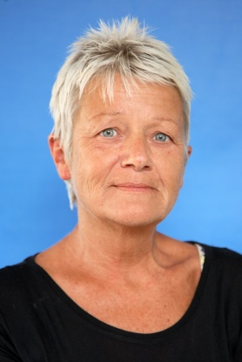 | Helen Butcher (Non Teacher Staff Member)  Member of the Learning and Curriculum Sub Committee  Early Years Governor  Appointed: September 2016  Helen is a Senior Learning Support Assistant based in Northampton General Hospital. She has 3 children and enjoys reading and cooking for friends and family. She also has a cat and a black Labrador.  Helen is an active volunteer for the Teenage Cancer Trust, Kids365 and the Ellen MacArthur Challenge where she supports children with cancer to take on sailing challenges.

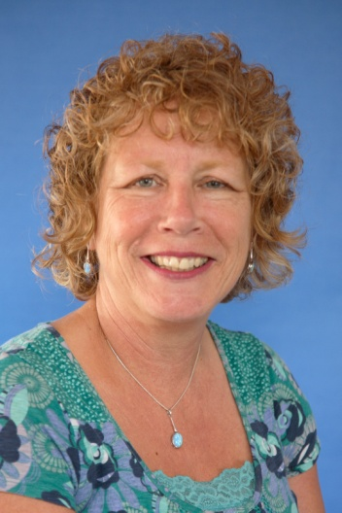 | Cath Kitchen (Head Teacher)  Cath has been a member of staff at Hospital and Outreach Education since 2000: previous to that, she has taught chemistry and biology to secondary aged pupils, and was Head of Early Years in another school. Cath was appointed as Head in September 2014.  Cath is passionate about inclusion and education of pupils with medical needs and is the chairperson of the National Association of Hospital and Home Teaching, and a member of the Pupil Referral Units and Alternative Provision Executive Committee.  Cath is married with 2 children and one grandchild

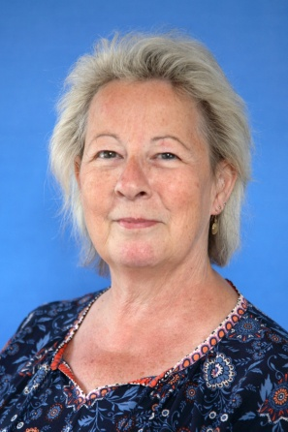 | Brenda Hunt (Deputy Head Teacher)  (Observer)  Brenda has been a member of Hospital and Outreach Education since 2000 starting as the teacher in charge in KGH and then as base manager when the first HOE base i.e. The Gatehouse, opened in 2003. Brenda and her husband have always lived and worked in Northamptonshire and she was educated locally and has a desire to see that all children and young people receive a high quality education. She initially taught secondary maths and science, has spent time teaching in a nursery setting and then 23 years in a primary setting including time as an acting Headteacher. Brenda is currently the Chair of Governors of a junior school and vice chair of a primary school.

Gerald Porter (Clerk to Governors)
Appointed: September 2014

